AWS TASK – 3

S3 Bucket:

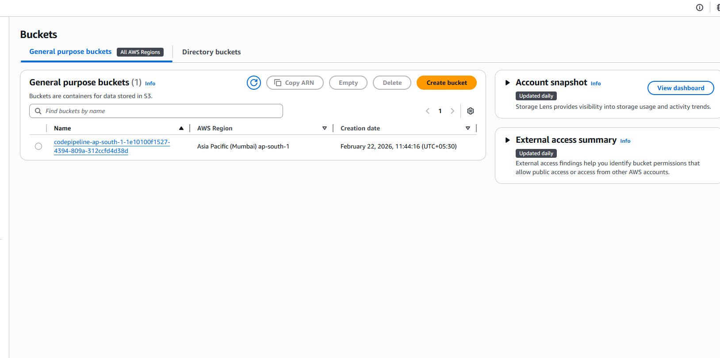

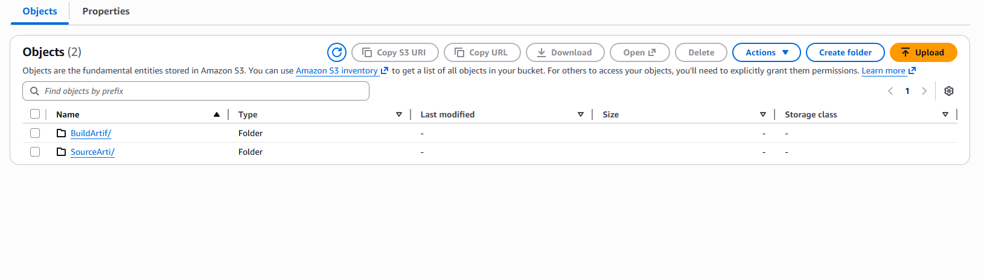

Cloud Watch:

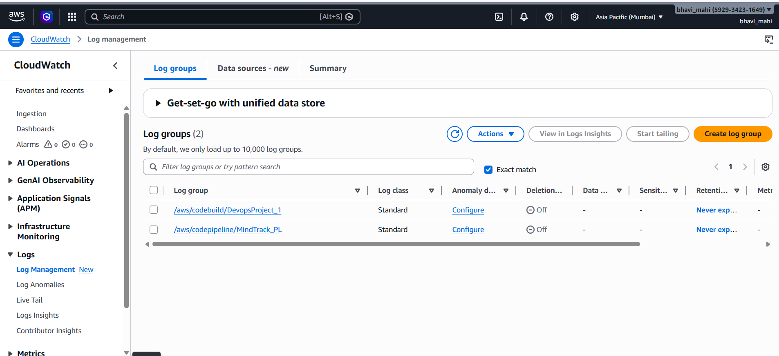

EC2:

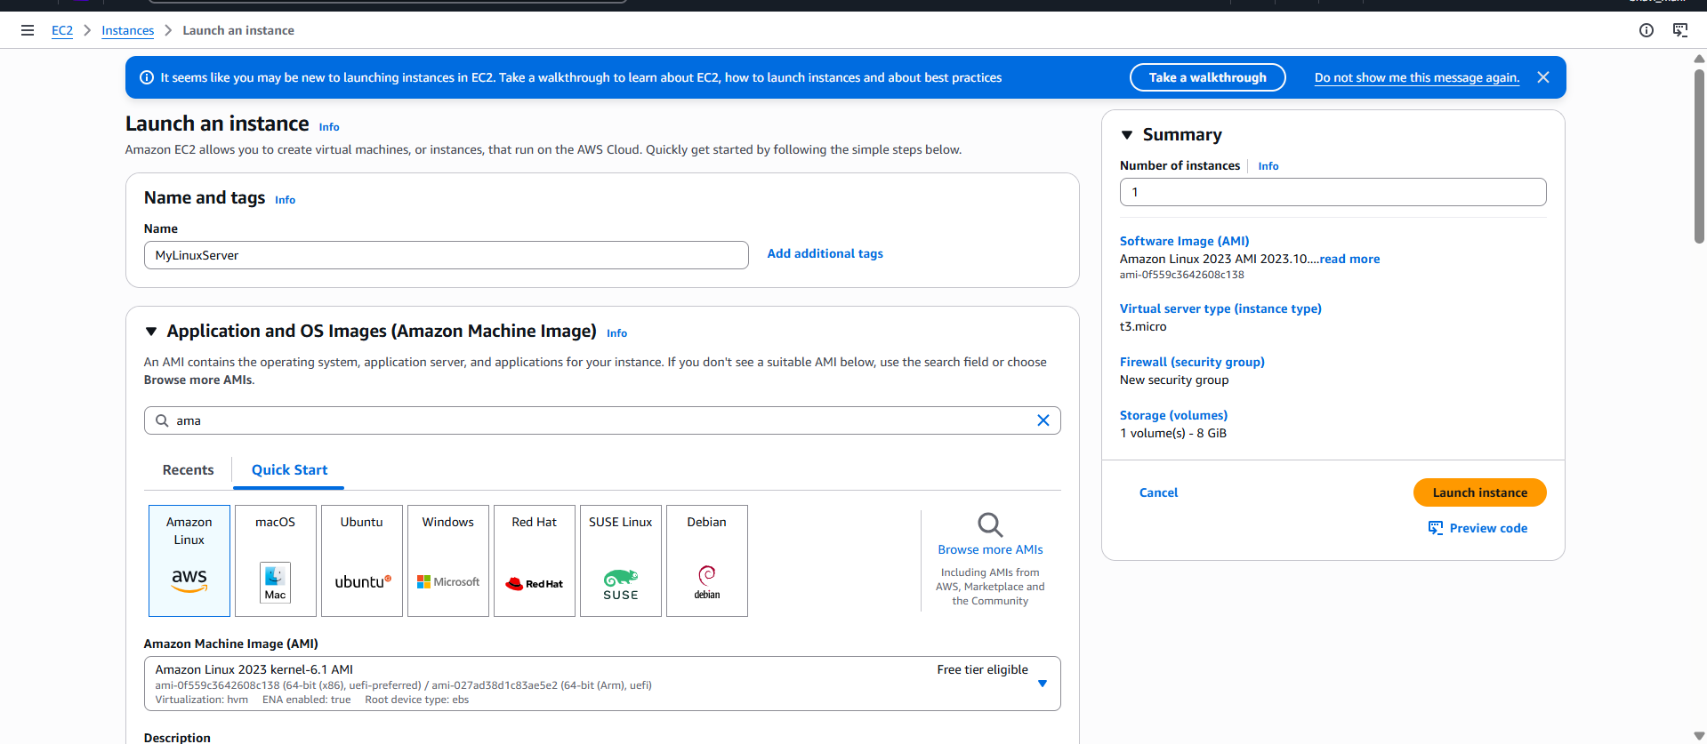

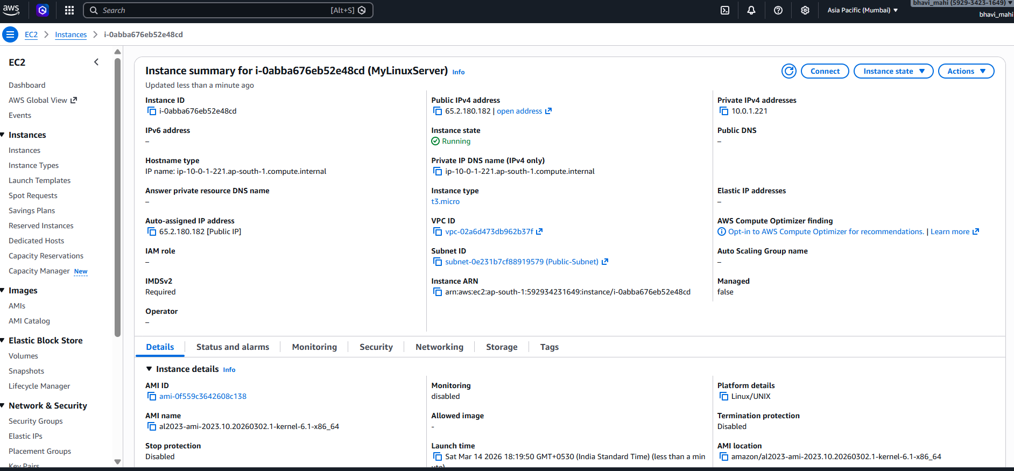

Install Web server:

ssh -i key.pem ec2-user@public-ip

Install nginx:
sudo yum update -y
sudo yum install nginx -y
sudo systemctl start nginx

echo "Hello from Server 1" | sudo tee /usr/share/nginx/html/index.html

Target Group:

Name: nginx-target-group
Type: Instances
Protocol: HTTP
Port: 80

Load Balancer:

Name: nginx-alb
Scheme: internet-facing
IP type: IPv4

nginx-alb-123456.us-east-1.elb.amazonaws.com

